Program No: 1 Date: 03.02.2026


<!DOCTYPE html>
<html lang="en" dir="ltr">
<head>
<meta charset="utf-8">
<title>Activity 2</title>
</head>
<body>
<h1 style='text-align:center;'><span style ="color:blue">G</span> <span style ="color:red">O</span> <span style ="color:yellow">O</span> <span style ="color:blue">G</span> <span style ="color:green">L</span> <span style ="color:red">E</span>
</body>
</html>

OUTPUT

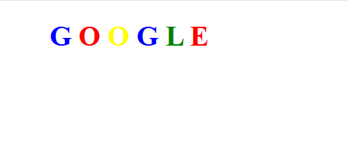

Program No: 2 Date: 06.02.2026
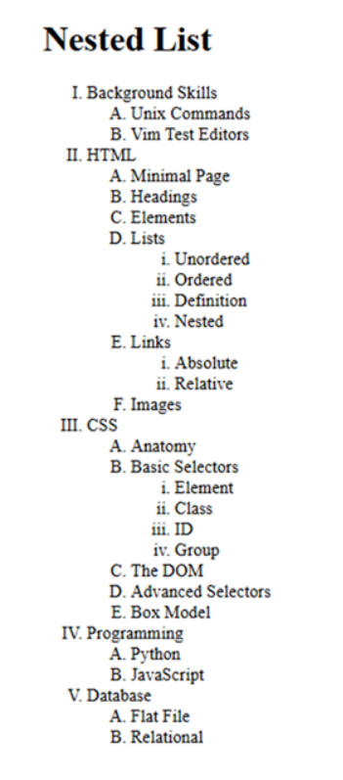

<!DOCTYPE html>
<html lang="en" dir="ltr">
<head>
<meta charset="utf-8">
<title>Activity 2</title>
</head>
<body>
<h2>Nested List</h2>
<ol type="I">
<li>Background Skills</li>
<ol type="A">
<li>Unix Commands</li>
<li>Vim Test Editors</li>
</ol>
<li>HTML</li>
<ol type="A">
<li>Minimal Page</li>
<li>Headings</li>
<li>Elements</li>
<li>Lists</li>
<ol type="i">
<li>Unordered</li>
<li>Ordered</li>
<li>Definition</li>
<li>Nested</li>
</ol>
<li>Links</li>
<ol type="i">
<li>Absolute</li>
<li>Relative</li>
</ol>
<li>Images</li>
</ol>
<li>CSS</li>
<ol type="A">
<li>Anatomy</li>
<li>Basic Selectors</li>
<ol type="i">
<li>Element</li>
<li>Class</li>
<li>ID</li>
<li>Group</li>
</ol>
<li>The DOm</li>
<li>Advanced Selectors</li>
<li>Box Model</li>
</ol>
<li>Programming</li>
<ol type="A">
<li>Python</li>
<li>JavaScript</li>
</ol>
<li>DataBase</li>
<ol types="A">
<li>Flat File</li>
<li>Relational</li>

</ol>
</ol>

</body>
</html>

OUTPUT
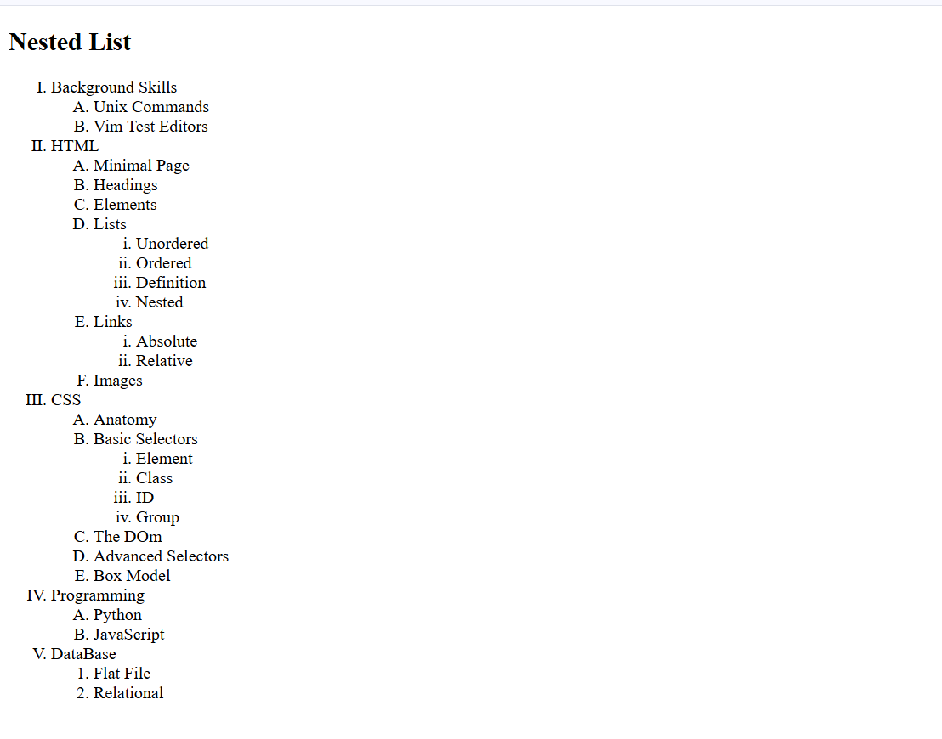

Program No: 3 Date: 06.02.2026
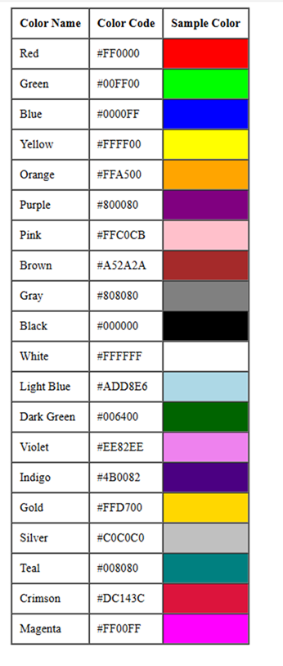

<!DOCTYPE html>
<html lang="en" dir="ltr">
<head>
<meta charset="utf-8">
<title>Table Color</title>
</head>
<body>
<table border='1'>
<tr>
<th>Color Name</th>
<th>Color Code</th>
<th>Sample Color</th>
</tr>

<tr>
<td>Red</td>
<td>#FF0000</td>
<td style="background-color:#FF0000"></td>
</tr>

<tr>
<td>Green</td>
<td>#00FF00</td>
<td style="background-color:#00FF00"></td>
</tr>

<tr>
<td>Blue</td>
<td>#0000FF</td>
<td style="background-color:#0000FF"></td>
</tr>

<tr>
<td>Yellow</td>
<td>#FFFF00</td>
<td style="background-color:#FFFF00"></td>
</tr>

<tr>
<td>Orange</td>
<td>#FFA500</td>
<td style="background-color:#FFA500"></td>
</tr>

<tr>
<td>Purple</td>
<td>#800080</td>
<td style="background-color:#800080"></td>
</tr>

<tr>
<td>Pink</td>
<td>#FFC0CB</td>
<td style="background-color:#FFC0CB"></td>
</tr>

<tr>
<td>Brown</td>
<td>#A52A2A</td>
<td style="background-color:#A52A2A"></td>
</tr>

<tr>
<td>Gray</td>
<td>#808080</td>
<td style="background-color:#808080"></td>
</tr>

<tr>
<td>Black</td>
<td>#000000</td>
<td style="background-color:#000000"></td>
</tr>

<tr>
<td>White</td>
<td>#FFFFFF</td>
<td style="background-color:#FFFFFF"></td>
</tr>

<tr>
<td>Light Blue</td>
<td>#ADD8E6</td>
<td style="background-color:#ADD8E6"></td>
</tr>

<tr>
<td>Dark Green</td>
<td>#006400</td>
<td style="background-color:#006400"></td>
</tr>

<tr>
<td>Violet</td>
<td>#EE82EE</td>
<td style="background-color:#EE82EE"></td>
</tr>

<tr>
<td>Indigo</td>
<td>#4B0082</td>
<td style="background-color:#4B0082"></td>
</tr>

<tr>
<td>Gold</td>
<td>#FFD700</td>
<td style="background-color:#FFD700"></td>
</tr>

<tr>
<td>Silver</td>
<td>#C0C0C0</td>
<td style="background-color:#C0C0C0"></td>
</tr>

<tr>
<td>Teal</td>
<td>#008080</td>
<td style="background-color:#008080"></td>
</tr>

<tr>
<td>Crimson</td>
<td>#DC143C</td>
<td style="background-color:#DC143C"></td>
</tr>

<tr>
<td>Magenta</td>
<td>#FF00FF</td>
<td style="background-color:#FF00FF"></td>
</tr>
</table>
</body>
</html>

OUTPUT
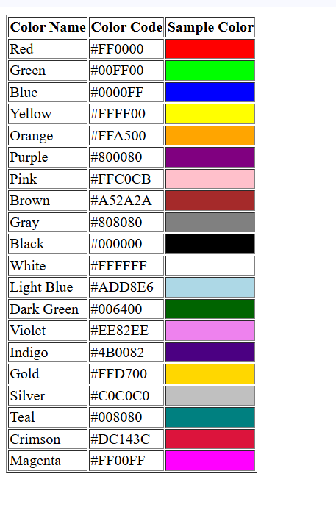

Program No: 4 Date: 13.02.2026
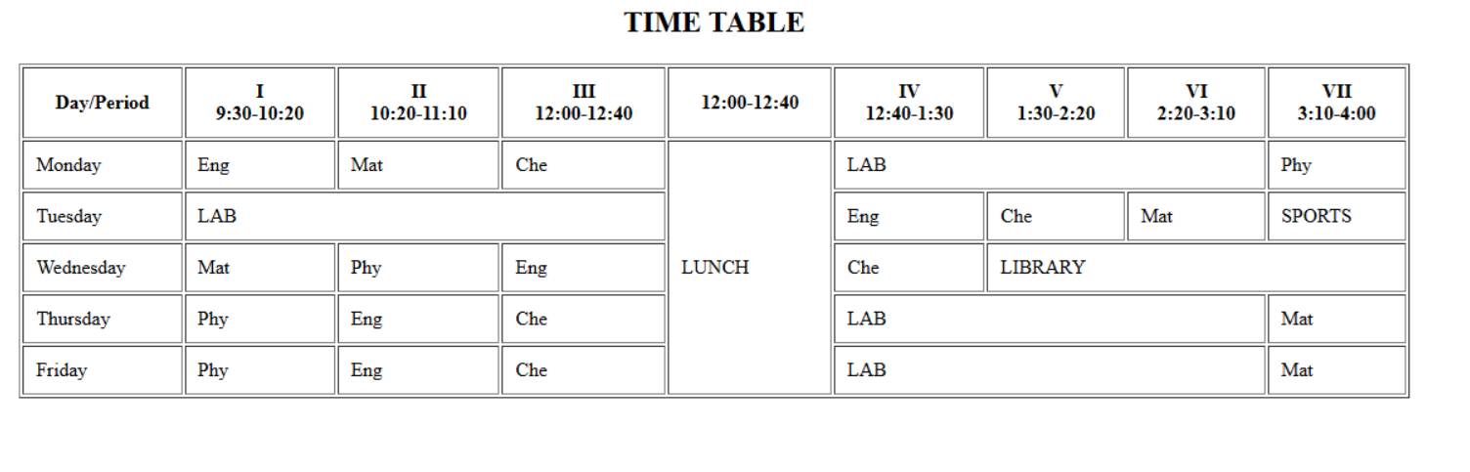

<!DOCTYPE html>
<html>
<head>
<title>Time Table</title>
</head>
<body>
<h2 align="center">TIME TABLE</h2>
<table border="1" cellspacing="0" cellpadding="8" align="center">

<tr>
<th>Day/Period</th>
<th>I<br>9:30-10:20</th>
<th>II<br>10:20-11:10</th>
<th>III<br>12:00-12:40</th>
<th>12:00-12:40</th>
<th>IV<br>12:40-1:30</th>
<th>V<br>1:30-2:20</th>
<th>VI<br>2:20-3:10</th>
<th>VII<br>3:10-4:00</th>
</tr>

<tr>
<td>Monday</td>
<td>Eng</td>
<td>Mat</td>
<td>Che</td>
<td rowspan="5">LUNCH</td>
<td colspan="3">LAB</td>
<td>Phy</td>
</tr>

<tr>
<td>Tuesday</td>
<td colspan="3">LAB</td>
<td>Eng</td>
<td>Che</td>
<td>Mat</td>
<td>SPORTS</td>
</tr>

<tr>
<td>Wednesday</td>
<td>Mat</td>
<td>Phy</td>
<td>Eng</td>
<td>Che</td>
<td colspan="3">LIBRARY</td>
</tr>

<tr>
<td>Thursday</td>
<td>Phy</td>
<td>Eng</td>
<td>Che</td>
<td colspan="3">LAB</td>
<td>Mat</td>
</tr>

<tr>
<td>Friday</td>
<td>Phy</td>
<td>Eng</td>
<td>Che</td>
<td colspan="3">LAB</td>
<td>Mat</td>
</tr>
</table>
</body>
</html>

OUTPUT
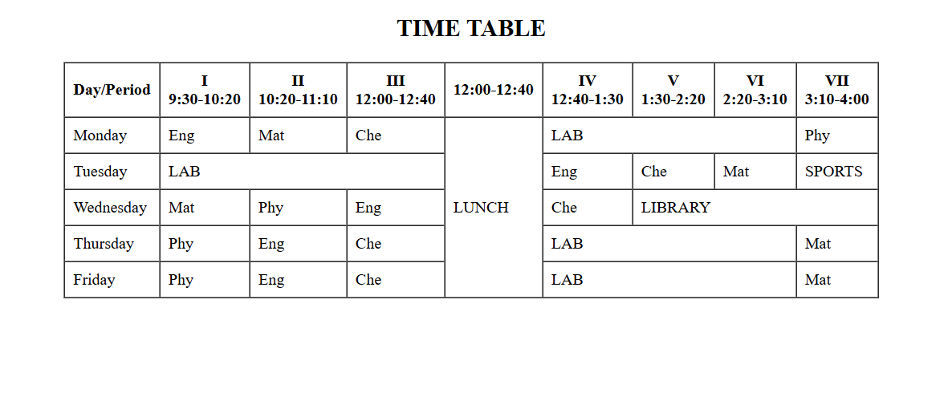

Program No: 5 Date: 13.02.2026
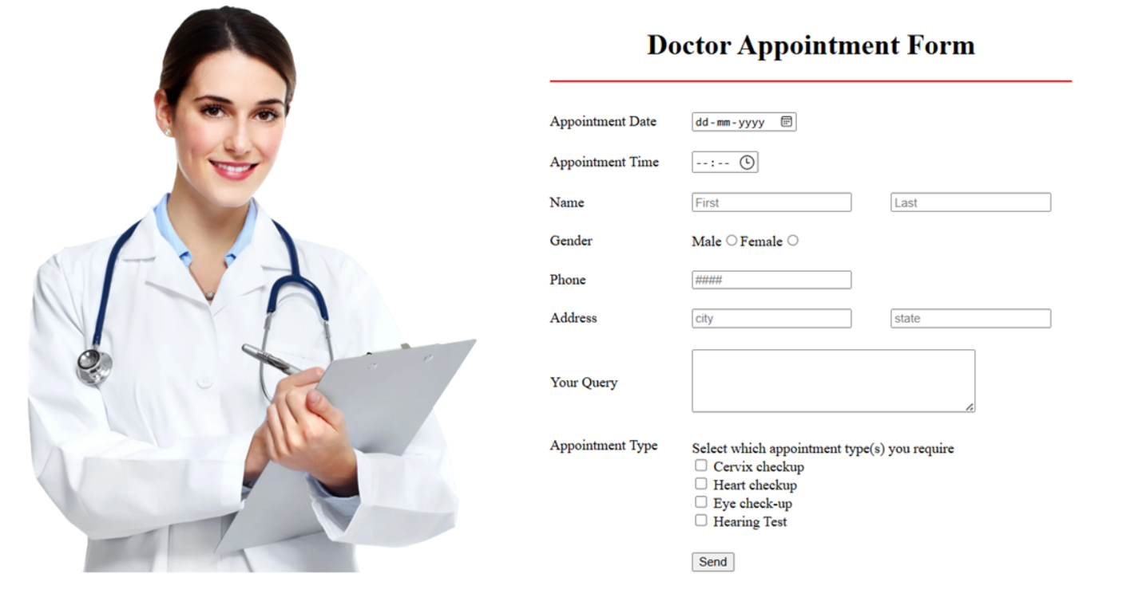
<!DOCTYPE html>
<html>
<head>
<title>Doctor Appointment Form</title>
<style>
body {
margin: 0;
font-family: Arial, sans-serif;
background-color: #ffffff;
}

.container {
display: flex;
align-items: center;
justify-content: center;
gap: 20px;
padding: 40px;
}

.doctor-img img {
width: 500px;
}

.form-section {
width: 700px;
}

h2 {
text-align: center;
font-size: 28px;
}

hr {
border: 1px solid red;
margin-bottom: 20px;
}

label {
display: inline-block;
width: 150px;
margin-top: 10px;
}

input, textarea {
padding: 5px;
margin-top: 10px;
margin-left: 10px;
margin-right: 10px;
}

textarea {
width: 300px;
height: 80px;
}

.checkbox-group {
margin-left: 150px;
}

button {
margin-top: 15px;
padding: 5px 15px;
}
</style>
</head>
<body>
<div class="container">
<div class="doctor-img">

<img src="https://imgs.search.brave.com/-R1DB8nN-FgXL8Twrdxph3nwTi_LESwr-bm0-mXsMLo/rs:fit:860:0:0:0/g:ce/aHR0cHM6Ly9tb29k/ZHAuY29tL3dwLWNv/bnRlbnQvdXBsb2Fk/cy8yMDI1LzEwL3do/YXRzYXBwLWRwLWRv/Y3Rvci53ZWJw" alt="Doctor">
</div>
<hr>
<div class="form-section">
<form id="appointmentForm" novalidate>
<h2>Doctor Appointment Form</h2>
<hr>
<label>Appointment Date</label>
<input type="date" id="appointmentDate" required><br>

<label>Appointment Time</label>
<input type="time" id="appointmentTime" required><br>

<label>Name</label>
<input type="text" id="firstName" placeholder="First" required>
<input type="text" id="lastName" placeholder="Last" required><br>

<label>Gender</label>
<input type="radio" name="gender" value="Male" required> Male
<input type="radio" name="gender" value="Female" required> Female<br>

<label>Phone</label>
<input type="tel" id="phone" placeholder="10-digit" pattern="[0-9]{10}" required><br>

<label>Address</label>
<input type="text" id="city" placeholder="city" required>
<input type="text" id="state" placeholder="state" required><br>

<label>Your Query</label>
<textarea id="query" required></textarea><br>

<label>Appointment Type</label>
<div class="checkbox-group">
<p>Select which appointment type(s) you require <br>
<input type="checkbox" name="appointmentType" value="Cervix checkup"> Cervix checkup<br>
<input type="checkbox" name="appointmentType" value="Heart checkup"> Heart checkup<br>
<input type="checkbox" name="appointmentType" value="Eye check-up"> Eye check-up<br>
<input type="checkbox" name="appointmentType" value="Hearing Test"> Hearing Test<br>
</p>
</div>
<div style="margin-left:150px;">
<button type="submit">Send</button>
</div>

<p id="formError" style="color: red; margin-left:150px;"></p>

</form>
</div>
</div>

<script>
const form = document.getElementById("appointmentForm");
const error = document.getElementById("formError");

form.addEventListener("submit", function (event) {
error.textContent = "";
if (!form.checkValidity()) {
event.preventDefault();
error.textContent = "Please fill all required fields correctly.";
return;
}
const checkedTypes = document.querySelectorAll("input[name='appointmentType']:checked");
if (checkedTypes.length === 0) {
event.preventDefault();
error.textContent = "Select at least one appointment type.";
}
});
</script>
</body>
</html>

OUTPUT
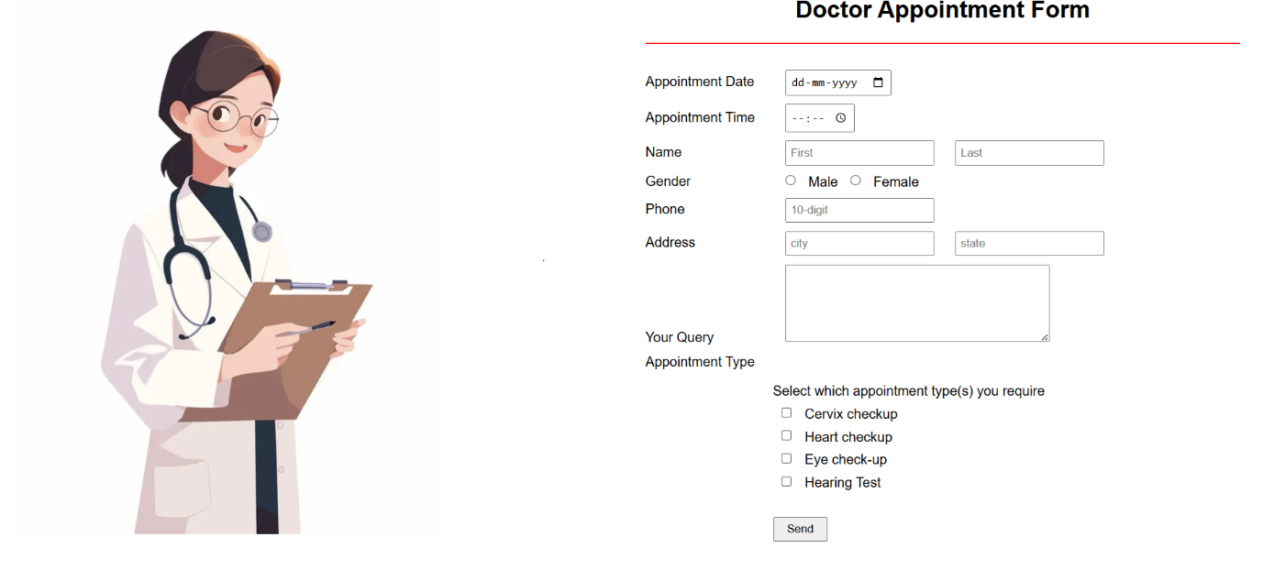

Program No: 6 Date: 20.02.2026
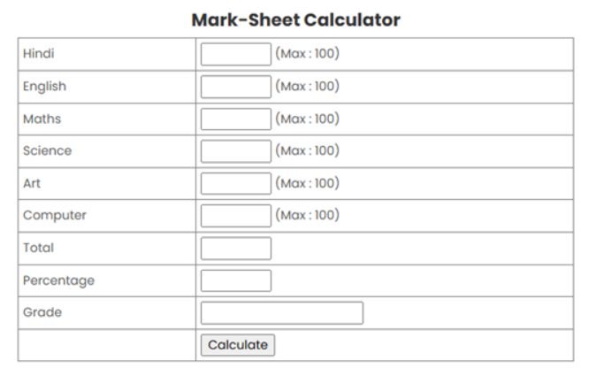

<!DOCTYPE html>
<html>
<head>
<title>Mark-Sheet Calculator</title>
</head>
<body>

<center>
<h2>Mark-Sheet Calculator</h2>

<table border="1" cellpadding="5" style="border-collapse: collapse;">
<tr>
<td>Hindi</td>
<td><input type="number" min="0" max="100" id="hindi" req> (Max : 100)</td>
</tr>
<tr>
<td>English</td>
<td><input type="number" min="0" max="100" id="english"> (Max : 100)</td>
</tr>
<tr>
<td>Maths</td>
<td><input type="number" min="0" max="100" id="maths"> (Max : 100)</td>
</tr>
<tr>
<td>Science</td>
<td><input type="number" min="0" max="100" id="science"> (Max : 100)</td>
</tr>
<tr>
<td>Art</td>
<td><input type="number" min="0" max="100" id="art"> (Max : 100)</td>
</tr>
<tr>
<td>Computer</td>
<td><input type="number" min="0" max="100" id="computer"> (Max : 100)</td>
</tr>

<tr>
<td>Total</td>
<td><input type="text" id="total" readonly></td>
</tr>
<tr>
<td>Percentage</td>
<td><input type="text" id="percent" readonly></td>
</tr>
<tr>
<td>Grade</td>
<td><input type="text" id="grade" readonly style="width: 100%;"></td>
</tr>

<tr>
<td colspan="2" align="center">
<button onclick="calculate()">Calculate</button>
</td>
</tr>
</table>
</center>

<script>
function calculate() {

let subjects = ["hindi","english","maths","science","art","computer"];
let total = 0;

for (let sub of subjects) {

let value = parseFloat(document.getElementById(sub).value);

if (isNaN(value)) {
alert("Please enter all marks.");
return;
}

if (value < 0 || value > 100) {
alert("Marks must be between 0 and 100 only.");
return;
}
total += value;
}

let percentage = (total / 600) * 100;

let grade = "";
if (percentage >= 90) grade = "A+ (Excellent)";
else if (percentage >= 80) grade = "A (Very Good)";
else if (percentage >= 70) grade = "B (Good)";
else if (percentage >= 60) grade = "C (Satisfactory)";
else if (percentage >= 50) grade = "D (Pass)";
else grade = "F (Fail)";

document.getElementById("total").value = total;
document.getElementById("percent").value = percentage.toFixed(2) + "%";
document.getElementById("grade").value = grade;
}
</script>
</body>
</html>

OUTPUT
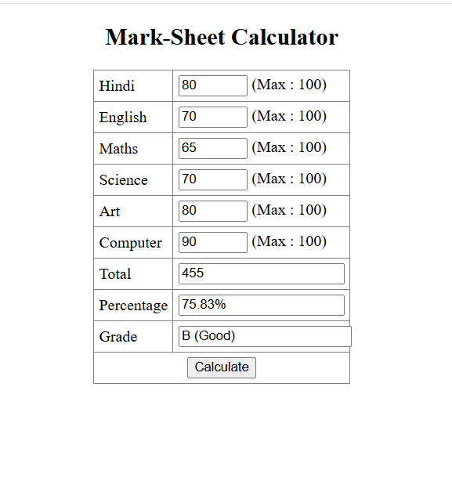

Program No: 7 Date: 20.02.2026
Online Quiz Generator with Result Summary
<!DOCTYPE html>
<html lang="en">
<head>
<meta charset="UTF-8">
<meta name="viewport" content="width=device-width, initial-scale=1.0">
<title>Online Test Result Summary</title>
<script>
function calculateScore()
{
let score = 0;
const totalQuestions = 5;
let i = 1;
for (i = 1; i <= totalQuestions; i++)
{
let answer = document.querySelector('input[name="q' + i + '"]:checked');

if (answer && answer.value === "correct") {
score++;
}
}
document.getElementById("result").innerHTML =
"Your score is: " + score + " / " + totalQuestions;
let percentage = (score / totalQuestions) * 100;
document.getElementById("percentage").innerHTML =
"Percentage: " + percentage + "%";
let passFail = (percentage >= 50) ? "Pass" : "Fail";
document.getElementById("passFail").innerHTML =
"Result: " + passFail;
}
</script>
</head>
<body>
<h1 align="center">Online Test: With Result Summary</h1>
<form id="quiz">
<p>1.JavaScript is a ___ language.</p>
<input type="radio" id="q1a1" name="q1" value="correct">
<label for="q1a1">Programming</label>
<br>
<input type="radio" id="q1a2" name="q1" value="wrong">
<label for="q1a2">Markup</label><br>

<p>2.HTML is a ___ language.</p>
<input type="radio" id="q2a1" name="q2" value="correct">
<label for="q2a1">Markup</label>
<br>
<input type="radio" id="q2a2" name="q2" value="wrong">
<label for="q2a2">Programming</label><br>

<p>3. Founder of HTML:</p>
<input type="radio" id="q3a1" name="q3" value="wrong">
<label for="q3a1">James Gosling</label>
<br>
<input type="radio" id="q3a2" name="q3" value="correct">
<label for="q3a2">Tim Berners-Lee</label>
<br>

<p>4. BootStrap is a ____</p>
<input type="radio" id="q4a1" name="q4" value="wrong">
<label for="q4a1">Scripting Language</label>
<br>
<input type="radio" id="q4a2" name="q4" value="correct">
<label for="q4a2">Front-End FrameWork</label><br>

<p>5.Which JavaScript method changes the content of an HTML element?</p>
<input type="radio" id="q5a1" name="q5" value="wrong">
<label for="q5a1">getElementById()</label>
<br>
<input type="radio" id="q5a2" name="q5" value="correct">
<label for="q5a2">innerHTML</label><br>

<input type="submit" value="Submit" onclick="calculateScore(); return false;">
</form>
<p id="result"></p>
<p id="percentage"></p>
<p id="passFail"></p>
</body>
</html>

OUTPUT
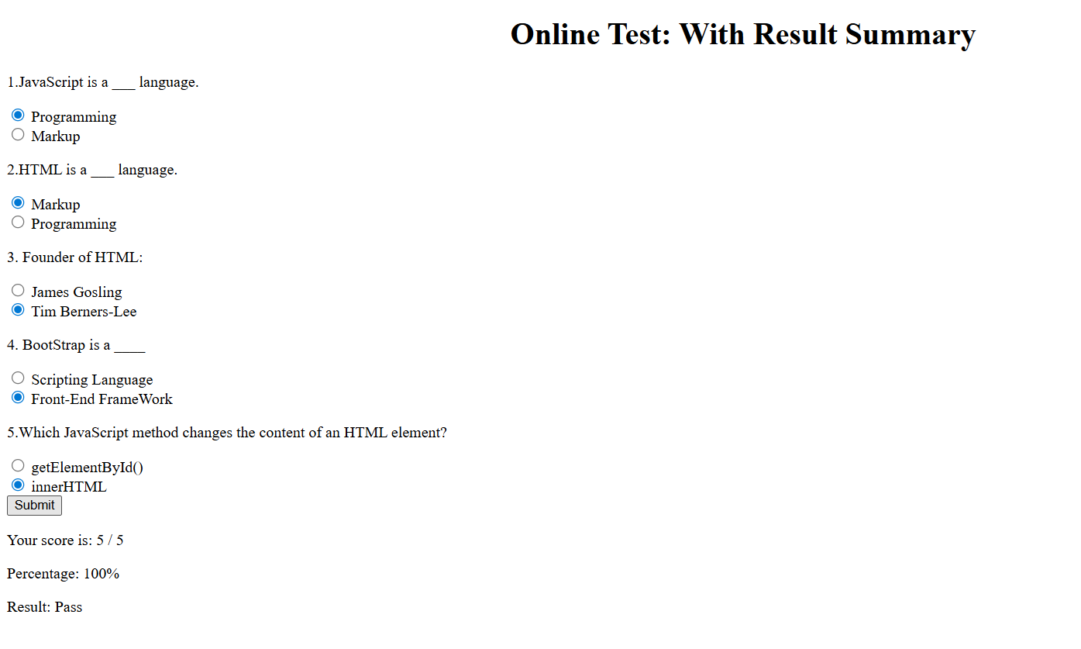

Program No: 8 Date: 27.02.2026
Student Management System with Add, Search and display
<!DOCTYPE html>
<html lang="en">
<head>
<meta charset="UTF-8">
<meta name="viewport" content="width=device-width, initial-scale=1.0">
<title></title>
<script>
function addStudent(){
const name = document.getElementById("name").value;
const course = document.getElementById("course").value;

if(name && course){
const table = document.getElementById("studentTable");
let row = table.insertRow();
let cell1 = row.insertCell(0);
let cell2 = row.insertCell(1);
cell1.innerHTML = name;
cell2.innerHTML = course;

document.getElementById("name").value = "";
document.getElementById("course").value = "";
} else {
alert("Please enter both name and course.");
}
}
function searchStudent()
{
const nameToSearch = document.getElementById("name").value.toLowerCase();
const table = document.getElementById("studentTable");

for (let i = 1; i < table.rows.length; i++)
{
const name = table.rows[i].cells[0].innerText.toLowerCase();

if (name === nameToSearch)
{
document.getElementById("searchResult").innerText =
"Found: " + table.rows[i].cells[0].innerText +
" - " + table.rows[i].cells[1].innerText;
return;
}
}

document.getElementById("searchResult").innerText = "Not Found";
}
</script>
</head>
<body>
<h1 align="center">Student Management</h1>
<form id="studentForm">
<label for="name">Name:</label>
<input type="text" id="name" name="name" required>
<br><br>
<label for="course">Course:</label>
<input type="text" id="course" name="course" required>
<br><br>
<button type="button" onclick="addStudent()">Add</button>
<button type="button" onclick="searchStudent()">Search</button>
</form>
<br>
<div id="searchResult" align="center"></div>
<br>
<table border="2" id="studentTable" align="center">
<tr>
<th>Name</th>
<th>Course</th>
</tr>
</table>
</body>
</html>

OUTPUT
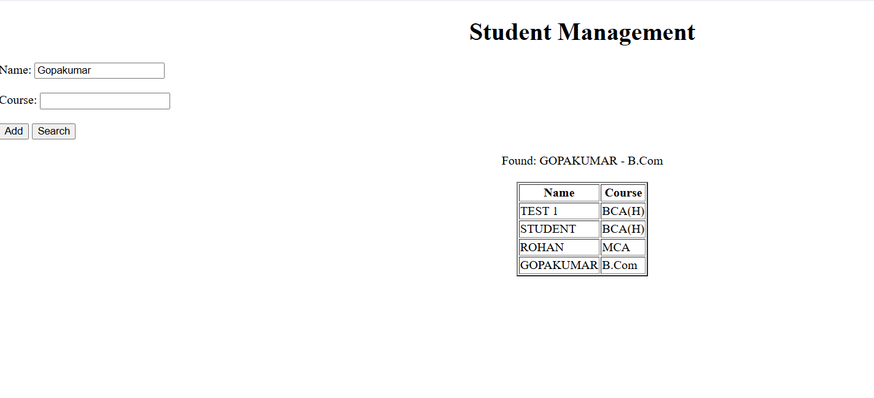

Program No: 9 Date: 27.02.2026
Registration Form Validation
<!DOCTYPE html>
<html lang="en">
<head>
<meta charset="UTF-8">
<title>Registration Page</title>
</head>
<body>

<h1>Registration Page</h1>

<form id="registrationForm">
<label>Name:</label>
<input type="text" id="name"><br><br>

<label>Email:</label>
<input type="text" id="email"><br><br>

<label>Password:</label>
<input type="password" id="password"><br><br>

<button type="submit">Register</button>
</form>

<script>
document.getElementById("registrationForm").addEventListener("submit", function(event)
{
event.preventDefault();

let name = document.getElementById("name").value.trim();
let email = document.getElementById("email").value.trim();
let password = document.getElementById("password").value;

if (name === "" || email === "" || password === "") {
alert("All fields are required.");
return;
}

if (!email.includes("@")) {
alert("Email must contain '@'.");
return;
}

if (password.length > 7) {
alert("Password must be Maximum 7 characters long.");
return;
}

alert("Registration successful!");
});
</script>
</body>
</html>

OUTPUT
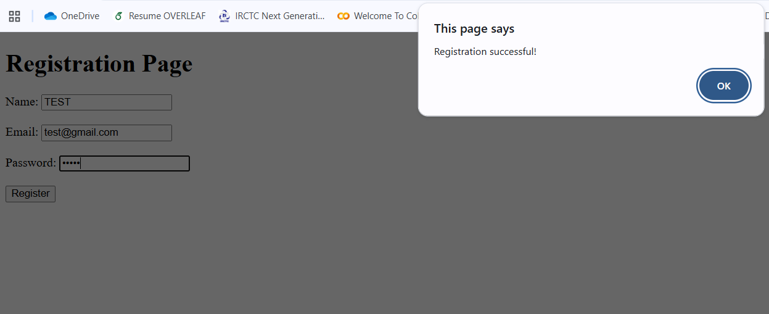

Program No: 10 Date: 27.02.2026
Create a form to check whether a user is eligible to vote (age ≥ 18)
<!DOCTYPE html>
<html lang="en">
<head>
<meta charset="UTF-8">
<title>Voting Eligibility</title>
</head>
<body>
<center>
<h1>Registration Page</h1>

<form id="registrationForm">
<table border="1" cellpadding="10" style="border-collapse: collapse;">
<tr>
<td><label>Name:</label></td>
<td><input type="text" id="name" placeholder="Your Name"></td>
</tr>

<tr>
<td><label>Date of Birth:</label></td>
<td><input type="date" id="dob"></td>
</tr>

<tr>
<td><label>Address:</label></td>
<td><textarea id="address" placeholder="Your Address"></textarea></td>
</tr>

<tr>
<td><label>Phone Number:</label></td>
<td><input type="tel" id="phone" placeholder="Phone Number"></td>
</tr>

<tr>
<td><label>Age:</label></td>
<td>
<span id="ageDisplay">Submit to calculate age</span>
</td>
</tr>

<tr>
<td colspan="2" align="center">
<button type="submit">Submit</button>
<button type="button" onclick="checkEligibility()">Check Eligibility</button>
</td>
</tr>

<tr>
<td colspan="2" align="center">
<div id="eligibilityResult"></div>
</td>
</tr>
</table>
</form>
</center>

<script>
document.getElementById("registrationForm").addEventListener("submit", function(event)
{
event.preventDefault();

let name = document.getElementById("name").value.trim();
let dob = document.getElementById("dob").value;
let address = document.getElementById("address").value.trim();
let phone = document.getElementById("phone").value.trim();

if (name === "" || dob === "" || address === "" || phone === "") {
alert("All fields are required!");
return;
}

let age = calculateAge(dob);
document.getElementById("ageDisplay").innerHTML = age;
});

function calculateAge(dobString) {
let today = new Date();
let birthDate = new Date(dobString);
let age = today.getFullYear() - birthDate.getFullYear();
let monthDiff = today.getMonth() - birthDate.getMonth();

if (monthDiff < 0 || (monthDiff === 0 && today.getDate() < birthDate.getDate())) {
age--;
}
return age;
}

function checkEligibility()
{
let name = document.getElementById("name").value.trim();
let dob = document.getElementById("dob").value;

if (name === "" || dob === "") {
alert("Please enter Name and Date of Birth first!");
return;
}

let age = calculateAge(dob);

if (age >= 18) {
document.getElementById("eligibilityResult").innerHTML =
"<b>User " + name + " is eligible for voting.</b>";
document.getElementById("eligibilityResult").style.color = "green";
} else {
document.getElementById("eligibilityResult").innerHTML =
"<b>User " + name + " is not eligible for voting.</b>";
document.getElementById("eligibilityResult").style.color = "red";
}
}
</script>
</body>
</html>
OUTPUT
